MORNING WORSHIP SERVICE
April 27, 2014

Instrumental Praise
Worship Hymn “I Shall Not Be Moved”
“Here I Am to Worship”

Prayer

Sunday School Report
Announcements Tami Knipstein
Welcome and Greeting
Birthdays and Anniversaries

Worship Hymn “Blessed Assurance” 334
“How great Is Our God”
“Glorify Thy Name” 249

Offering/Offertory

Scripture Reader Kristi Suchomel
Philippians 1:3 – 8; 4:10 - 20

Message Brother Dwight Reagan
Your Partnership in the Gospel

Invitation “Take My Life, Lead Me Lord” 287
Departing Song “Only Believe” 534
Instrumental Praise

NURSERY – available for children age 0 to Kindergarten
(0-2) Becky Yount, (3-K) Kristi Suchomel, (Helper)

Hostesses for April Ushers for April
Carolyn Bailey, Hugo Breithaupt Mickey Stanford, Geary McManus
Sheila Waggoner, Judie Coffey Hugo Breithaupt, Joe Wilson

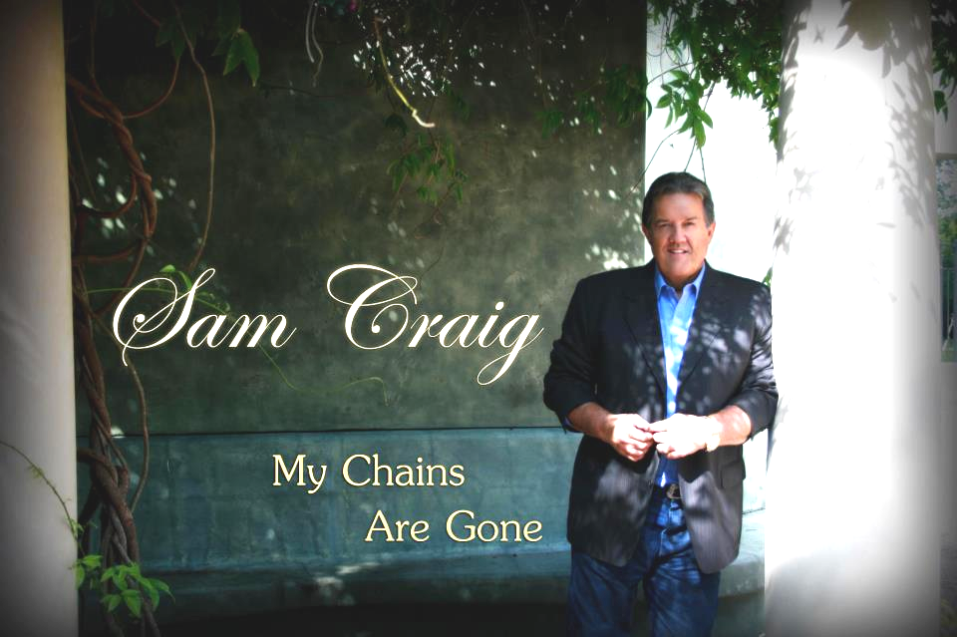
TONIGHT at 6:00 p.m.

Long Term Prayer List

Helen Whitten Bill Gravell Wanda Dodd Geary McManus

Frank Joyce Bobby Coffey Charlene Laurence Micah Alston

Jim Morgan Danny Sherman Helen Emery Dolly Hester

Bobby Stutes Marshall Self Josh Bryant Geneva Davis

Kaeli Farris Kelly Long Leon Grohman Sheila Waggoner

Al Moreno Linda Kelly Phillip Hendricks Kenneth Williams

Ashleigh Self Lonnie McCoy Joy Muery Pete Turnipseed

Jenny Jones Leslie Snider Iva Long Rabelle King

Kathy Larkin Michaella Potts Dorothy York Margie McElwee

Richard Hill Raechel Hill Esther Seber Joe Goodson

Margaret Glossup Ruth Bostic Ann Skinner Mickey Stanford

Georgia Gravell Parker Connie Kahlstrom – Rehab Lorene Beauchamp

Ken Beauchamp/Family Esther Collins - Cancer Tommy & Brenda Luellen

Cody/Kayla Ruthven/Family – NIH Drug Trial

Immediate Need Prayer List
** Pray for Our Church & Church Family, those with unspoken needs, & those who are out of work!

** Please pray for our church families that are struggling.

** Pray for Dylan Scheel – son of Richard and Meggins Scheel – who is home from the hospital recovering from a bacterial infection.

** Pray for Connie Kahlstrom who is in rehab in Giddings after being taken to the hospital for dehydration and low blood pressure.

** Prayers & Sympathy to the Family & Friends of Ruby Cain who passed away.

Prayer & Request Information

(Please complete name & address information on reverse side)

❑ I would like to speak with the Pastor.

❑ I would like more information on this church.

❑ I have Prayer Requests or Needs

Prayer Request Form

Date:

Permission to Publicize:
Church Bulletin  Yes  No
Email Prayer Chain  Yes  No

Prayer Request:

Prayer For
Name
Address
Phone

Given By
Name
Address
Phone

Please Contact By
❑ Card  Phone  Visit

Comments

